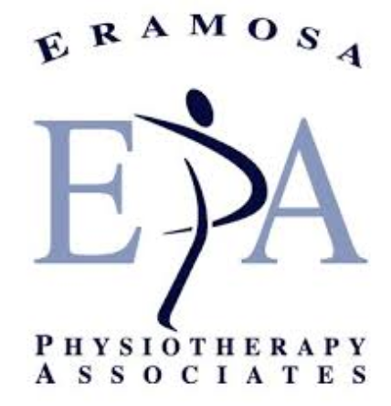
Reminder Preferred Provider Program with Eramosa Physiotherapy
We wanted to remind you that CLGW has partnered with Eramosa Physiotherapy to provide you with a Preferred Provider Program. The following describes how the program works and other information.
How Does This Program Work?
Eramosa Physiotherapy uses the most up-to-date, research-supporting physiotherapy to help you with any physical injuries or illnesses that you have.
Eramosa Physiotherapy has assisted with helping our staff at CLGW recover from work and non-related injuries. Their knowledgeable Physiotherapists are familiar with our work environment and have provided assistance and education in some of our group home locations. Since they are familiar with what you do at work they can better assist you in your treatment plan.
Since Eramosa Physiotherapy has a partnership with CLGW then there is an increase in the communication when it comes to workplace or even non-workplace injuries. With your permission, Eramosa Physiotherapy will inform your family physician about your proposed treatment and if necessary, make recommendations regarding returning to work or the need for further investigative tests, such as x-rays. Eramosa Physiotherapy is also open to communicating with alternative healthcare providers, such as sports coaches and personal trainers that you may be working with. This communication enhances the quality of your treatment, ensures the use of appropriate resources and reduces your need to facilitate the transfer of information to your healthcare practitioner.
If you have a work-related injury that may require physiotherapy, CLGW will recommend that you make an appointment with Eramosa Physiotherapy who will schedule you for an appointment within 3 business days of contact.
If you have a non-work, Eramosa Physiotherapy can keep CLGW abreast of your progress, but only if you sign a waiver form allowing us to communicate with you. Otherwise it's a breach of confidentiality.
For more information about Eramosa Physiotherapy, please visit their website at https://eramosaphysio.com.
Where Are They Located?
They have several locations in and near the Guelph Wellington area such as; Acton, Burlington, Elora, Georgetown, Guelph, Hespeler and Orangeville. For more information about their locations, please visit their website at https://eramosaphysio.com/our-locations/.



