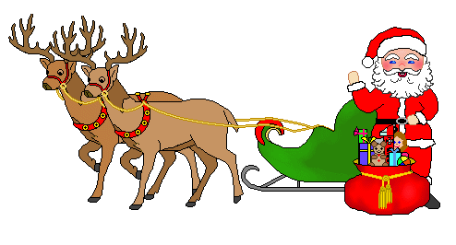

It’s not that far away!!!

**Community Living Guelph Wellington Children’s Christmas Party**

**Sponsored by CLGW and CUPE 4392**

**(North) Cost: $15 per child**

**When: November 30th 10 am-1pm**

106 Thomas St., Harriston Ontario

Chuckles will be here to make balloons for the children

*Parent Name and phone number where you can be reached in case of inclement weather:  
  
_____________________________________________ ______________________________

Name: __________________________________________________ Age: ______________

Likes/Dislikes: ____________________________________________ (Gift Suggestion)

Name: __________________________________________________ Age: ______________

Likes/Dislikes: ____________________________________________ (Gift Suggestion)

Name: __________________________________________________ Age: ______________

Likes/Dislikes: ____________________________________________ (Gift Suggestion)

Name: __________________________________________________ Age: ______________

Likes/Dislikes: ____________________________________________ (Gift Suggestion)

**\*\*\*\*\*\*\*\*\*\*\*\*\*\*\*\*\*\*Please have this sheet and money/cash $$ into either Michele deBoer 519-835-9234 or Tammy Stewart 519-580-5493 by November 15th. \*\*\*\*\*\*\*\*\*\*\*\*\*\*\*\*\*\*\*\*\*\*\*\*\*\*\*\*\*\*\*\*\*\*\*\*\*\*\*\*\***

**We will accept etransfer if you prefer-micheledeboer@live.ca**